Chapter-I
HYDROSTATICS

Hydrostatic is that branch of science which relating to fluids at rest or to the pressures they exert or transmit Hydrostatic Pressure.
Fluid:-
Fluid is a substance that continuously deforms (flows) under an applied shear stress. Fluids are a subset of the phase of matter and include liquids, gases, plasmas and, to some extent, plastic solids. Fluids can be defined as substances which have zero shear modulus or in simpler terms a fluid is a substance which cannot resist any shear force applied to it.
- Fluid is a substance which is capable of flowing
- Conform the shape of the containing vessel
- Deform continuously under application of small shear force
1.1 PROPERTIES OF FLUID:-

Density:-
The density of a fluid, is generally designated by the Greek symbol is defined as the mass of the fluid over a unit volume of the fluid at standard temperature and pressure. It is expressed in the SI system as kg/m³.
$ρ=\text{lim}\frac{Δm}{ΔV}=\frac{\text{dm}}{\text{dV}}$
If the fluid is assumed to be uniformly dense the formula may be simplified as:
$ρ=\frac{m}{V}$
Example: - setting of fine particles at the bottom of the container.

Specific Weight:-
The specific weight of a fluid is designated by the Greek symbol (gamma), and is generally defined as the weight per unit volume of the fluid at standard temperature and pressure. In SI systems the units is N/m³.
$$λ=ρ∗g$$
g = local acceleration of gravity and ρ = density
Note: It is customary to use:
g = 32.174 ft/s² = 9.81 m/s²
ρ = 1000 kg/m³

Relative Density (Specific Gravity):-
The relative density of any fluid is defined as the ratio of the density of that fluid to the density of the standard fluid. For liquids we take water as a standard fluid with density ρ=1000 kg/m³. For gases we take air or O₂ as a standard fluid with density, ρ=1.293 kg/m³.
Specific volume:-
Specific volume is defined as the volume per unit mass. It is just reciprocal of mass density. It is expressed in m³/kg.

Viscosity:-
Viscosity (represented by μ, Greek letter mu) is a material property, unique to fluids, that measures the fluid's resistance to flow. Though a property of the fluid, its effect is understood only when the fluid is in motion. When different elements move with different velocities, each element tries to drag its neighboring elements along with it. Thus, shear stress occurs between fluid elements of different velocities.
Viscosity is the property of liquid which destroyed the relative motion between the layers of fluid.
- It is the internal friction which causes resistance to flow.
- Viscosity is the property which control the rate of flow of liquid
Viscosity is due to two factors-
- Cohesion between the liquid molecules.
- Transfer of momentum between the molecules.
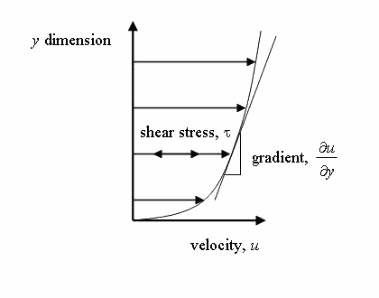
Fig. 1.1
The relationship between the shear stress and the velocity field was that the shear stresses are directly proportional to the velocity gradient. The constant of proportionality is called the coefficient of dynamic viscosity.
$$τ=μ\frac{∂u}{∂y}$$
UNIT OF VISCOSITY
- In mks system unit of viscosity is kgf-sec/m²
- In cgs system unit of viscosity is dyne-sec/cm²
- In S.I system unit of viscosity is Newton-sec/m²
Kinematic viscosity:-
Another coefficient, known as the kinematic viscosity (, Greek nu) is defined as the ratio of dynamic viscosity and density.
I.et, $υ=μ/ρ$ = viscosity/density
In mks & S.I system unit of kinematic viscosity is meter²/sec
In cgs system unit of kinematic viscosity is stoke.
SURFACE TENSION:-
Surface tension is defined as the tensile force acting on the surface of a liquid in contact with a gas or on the surface between two immiscible liquids such that the contact surface behaves like a membrane under tension. The magnitude of this force per unit length of the free surface will have the same value as the surface energy per unit area. It is denoted by Greek letter sigma(σ). In MKS units, it is expressed as kgf/m while in SI unit is N/m.
It is also defined as force per unit length, or of energy per unit area. The two are equivalent—but when referring to energy per unit of area, people use the term surface energy—which is a more general term in the sense that it applies also to solids and not just liquids.
Capillarity:-
Capillarity is defined as a phenomenon of rise or fall of a liquid surface in a small tube relative to the adjacent general level of liquid when the tube is held vertically in the liquid. The rise of liquid surface is known as capillary rise while the fall of the liquid surface is known as capillary depression. It is expressed in terms of cm or mm of liquid. Its value depends upon the specific weight of the liquid, diameter of the tube and surface tension of the liquid.
1.2 Pressure and its measurement:-
INTENSITY OF PRESSURE:-
Intensity of pressure is defined as normal force exerted by fluid at any point per unit area. It is also called specific pressure or hydrostatic pressure
P=df/da
- If intensity of pressure is uniform over an area “A” then pressure force exerted by fluid equal to
Mathematically F=PA
- If intensity of pressure is not uniform or vary point to point then pressure force exerted by fluid equal to integration of P*A
Mathematically F=ʃ PA
- Unit of pressure
    - 1N/m² =1 Pascal
    - 1KN/m²= 1 kilo Pascal
    - Kilo Pascal= 1kpa = 10³ Pascal
    - 1 bar = 10⁵ Pascal = 10⁵ N/m²

Pascal’s law:-
It states that the pressure or intensity of pressure at a point in a static fluid is equal in all direction.
Atmospheric Pressure:-
The atmospheric air exerts a normal pressure upon all surface with which it is in contact and it is called atmospheric pressure. It is also called parametric pressure.
Atmospheric pressure at the sea level is called standard atmospheric pressure.
S.A.P = 101.3 KN/m² = 101.3 kpa = 10.3m of H₂O
= 760 mm of Hg
=10.3 (milli bar)
Gauge pressure:-
It is the pressure which measure with help of pressure measuring device in which atmospheric pressure taken as datum.
The atmospheric pressure on scale is marked as zero.
Absolute pressure:-
Any pressure measure above absolute zero pressure is called absolute pressure.
Vacuum pressure:-
Vacuum pressure is defined as the pressure below the atmospheric pressure.
RELATIONSHIP BETWEEN ABSOLUTE PRESSURE, GAUGE PRESSURE, VACUUM PRESSURE:-
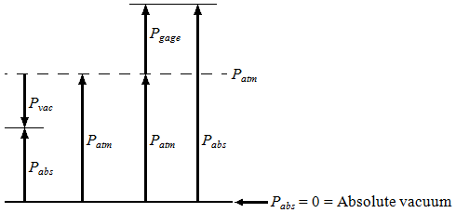
Fig. 1.2

- Equations
P_{gage} = P_{abs} – P_{atm} | gauge pressure
P_{vac} = P_{atm} – P_{abs} | vacuum pressure
P_{abs} = P_{atm} + P_{gage} | absolute pressure
- Nomenclature
P_{abs} | absolute pressure
P_{gage} | gage pressure
P_{vac} | vacuum pressure
P_{atm} | atmospheric pressure
Pressure Head:-
pressure head is the internal energy of a fluid due to the pressure exerted on its container. It may also be called static pressure head or simply static head (but not static head pressure). It is mathematically expressed as:
$ψ=\frac{p}{γ}=\frac{p}{ρg}$
where
is pressure head (Length, typically in units of m);
is fluid pressure (force per unit area, often as Pa units); and
is the specific weight (force per unit volume, typically N/m³ units)
is the density of the fluid (mass per unit volume, typically kg/m³)
is acceleration due to gravity (rate of change of velocity, given in m/s²)
If intensity of pressure express in terms of height of liquid column, which causes pressure is also called pressure head.
Mathematically, h= P/w
Pressure Gauges :-
The pressure of a fluid is measured by the following devices:-
- manometers
- mechanical gauges
Manometers:-Manometers are defined as the devices used for measuring the pressure at a point in a fluid by balancing the column of fluid by the same or another column of the fluid. They are classified as:
- Simple manometers
- Differential manometer
Mechanical gauges:-mechanical gauges are defined as the devices used for measuring the pressure by balancing the fluid column by the spring or dead weight. The commonly used mechanical gauges are:-
- Diaphragm pressure gauge
- Bourdon tube pressure gauge
- Dead weight pressure gauge
- Bellows pressure gauge
1.3 PRESSURE EXERTED ON IMMERSED SURFACE:-
Hydrostatic forces on surfaces:-
Hydrostatic means the study of pressure exerted by a liquid at rest. The direction of such pressure is always perpendicular to the surface to which it acts.
Forces on Submerged Surfaces in Static Fluids
These are the following features of statics fluids:-
- Hydrostatic vertical pressure distribution
- Pressures at any equal depths in a continuous fluid are equal
- Pressure at a point acts equally in all directions (Pascal's law).
- Forces from a fluid on a boundary acts at right angles to that boundary.

Fluid pressure on a surface:-
Pressure is defined as force per unit area. If a pressure p acts on a small area δA then the force exerted on that area will be
$$F=pδA$$
TOTAL PRESSURE:-
Total pressure is defined as the force exerted by a static fluid on a surface when the fluid comes in contact with the surface.
Mathematically total pressure,
P=p₁a₁ + p₂a₂+ p₃a_{3………….}
Where,
- p₁, p₂, p₃ = Intensities of pressure on different strips of the surface, and
- a₁, a₂, a₃ = Areas of corresponding strips.
The position of an immersed surface may be,
- Horizontal
- Vertical
- Inclined

Total Pressure On A Horizontal Immersed Surface
Consider a plane horizontal surface immersed in a liquid as shown in figure 1.
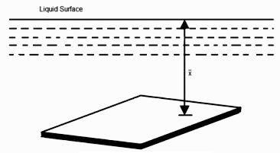
Fig. 1.3
- $ω=$Specific weight of the liquid
- $A=$Area of the immersed surface in in²
- $χ$= Depth of the horizontal surface from the liquid level in meters
We know that the Total pressure on the surface,
P = Weight of the liquid above the immersed surface
= Specific weight of liquid * Volume of liquid
= Specific weight of liquid * Area of surface * Depth of liquid
= $ωAχ\text{kN}$

Total Pressure On A Vertically Immersed Surface
Consider a plane vertical surface immersed in a liquid shown in figure 2.
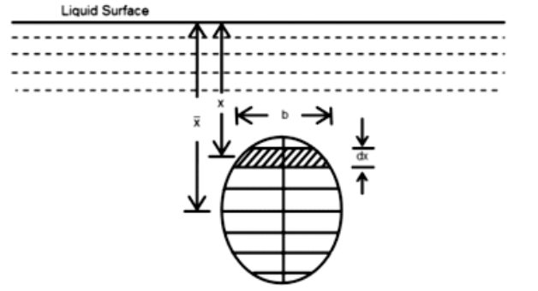
Fig. 1.4
Let the whole immersed surface is divided into a number of small parallel stripes as shown in figure.
Here,
- $ω=$ Specific weight of the liquid
- A = Total area of the immersed surface
- $χ$= Depth of the center of gravity of the immersed surface from the liquid surface
Now, consider a strip of thickness dx, width b and at a depth x from the free surface of the liquid.
The intensity of pressure on the strip = $\text{ωχ}$
and the area of strip =b.dx
Pressure on the strip = Intensity of pressure * Area = $\text{ωχ}$.bdx
Now, Total pressure on the surface,
$P=\int{\text{wx}\text{.}\text{bdx}}$.
$$=w\int{x\text{.}\text{bdx}}$$
But, $w\int{x\text{.}\text{bdx}}$= Moment of the surface area about the liquid level = $A\bar{x}$
$$∴P=\text{wA \{}\bar{x}$$
1.4 FLOTATION AND BUOYANCY:-
Archimedes Principle:-

Archimedes' principle indicates that the upward buoyant force that is exerted on a body immersed in a fluid, whether fully or partially submerged, is equal to the weight of the fluid that the body displaces. Archimedes' principle is a law of physics fundamental to fluid mechanics. Archimedes of Syracuse formulated this principle, which bears his name.
Buoyancy:-
When a body is immersed in a fluid an upward force is exerted by the fluid on the body. This is upward force is equal to weight of the fluid displaced by the body and is called the force of buoyancy or simple buoyancy.
Centre of pressure:-
The center of pressure is the point where the total sum of a pressure field acts on a body, causing a force to act through that point. The total force vector acting at the center of pressure is the value of the integrated pressure field. The resultant force and center of pressure location produce equivalent force and moment on the body as the original pressure field. Pressure fields occur in both static and dynamic fluid mechanics. Specification of the center of pressure, the reference point from which the center of pressure is referenced, and the associated force vector allows the moment generated about any point to be computed by a translation from the reference point to the desired new point. It is common for the center of pressure to be located on the body, but in fluid flows it is possible for the pressure field to exert a moment on the body of such magnitude that the center of pressure is located outside the body.
Center of buoyancy:-
It is define as the point through which the force of buoyancy is supposed to act. As the force of buoyancy is a vertical force and is equal to the weight of the fluid displaced by the body, the center of buoyancy will be the center of gravity of the fluid displaced.
METACENTER:-
The metacentric height (GM) is a measurement of the initial static stability of a floating body. It is calculated as the distance between the centre of gravity of a ship and its metacentre. A larger metacentric height implies greater initial stability against overturning. Metacentric height also has implication on the natural period of rolling of a hull, with very large metacentric heights being associated with shorter periods of roll which are uncomfortable for passengers. Hence, a sufficiently high but not excessively high metacentric height is considered ideal for passenger ships.
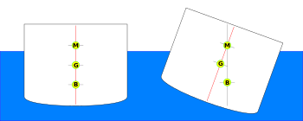
Fig. 1.5
The metacentre can be calculated using the formulae:
KM=KB+BM
$$\text{BM}=\frac{I}{V}$$
Metacentric height:-
The distance between the meta-center of a floating body and a center of gravity of the body is called metacentric height.
MG =BM-BG
MG=I/V-BG
Stability of a submerged body:-

Stable condition:-
- For stable condition w = f_{b} and the point “B” above the CG of the body.
Unstable equilibrium;-
- For unstable equilibrium w = f_{b} and the point B is below the CG of the body.
Neutral equilibrium:-
- If the force of buoyancy is act as CG of the body.
Stability of a floating body:-
- For stable condition w = f_{b} and the meta centre “m” is about the CG of the body.
- For unstable equilibrium w = f_{b} and the metacentre “m” is below CG of the body.
- In neutral equilibrium w = f_{b} and metacentre “m” is acting at CG of the body.
Chapter-II
KINEMATICS OF FLUID FLOW

2.1 Basic equation of fluid flow and their application:-

Energy of a Liquid in Motion:-
The energy, in general, may be defined as the capacity to do work. Though the energy exits in many forms, yet the following are important from the subject point of view:
1. Potential energy,
2. Kinetic energy, and
3. Pressure energy.

Potential Energy of a Liquid Particle in Motion:-
It is energy possessed by a liquid particle by virtue of its position. If a liquid particle is Z m
above the horizontal datum (arbitrarily chosen), the potential energy of the particle will be Z metre-kilogram (briefly written as mkg) per kg of the liquid. The potential head of the liquid, at
point, will be Z metres of the liquid.

Kinetic Energy of a Liquid Particle in Motion:-
It is the ehergy, possessed by a liquid particle, by virtue of its motion or velocity. If a liquid particle is flowing with a mean velocity of v metres per second; then the kinetic energy of the particle will be V²/2g mkg per kg of the liquid. Velocity head of the liquid, at that velocity, will be V²/2g metres of the liquid.

Pressure Energy of a Liquid Particle in Motion:-
It is the energy, possessed by a liquid particle, by virtue of its existing pressure. If a liquid particle is under a pressure of p kN/m2 (i.e., kPa), then the pressure energy of the particle-will be $\frac{p}{w\text{.}}$ mkg per kg of the liquid, where w is the specific weight of the liquid. Pressure head of the liquid
under that pressure will be metres of the liquid.

Total Energy of a Liquid Particle in Motion:-
The total energy of a liquid, in motion, is the sum of its potential energy, kinetic energy and pressure energy, Mathematically total energy,
E = Z + V²/2g + m of Liquid.
Total Head of a Liquid Particle in Motion:-
The total head of a liquid particle, in motion, is the sum of its potential head, kinetic head and pressure head. Mathematically, total head,
H = Z + V²/2g + $\frac{p}{w\text{.}}$m of liquid.
Example
Water is flowing through a tapered pipe having end diameters of 150 mm and 50 mm respectively. Find the discharge at the larger end and velocity head at the smaller end, if the velocity of water at the larger end is 2 m/s. Solution. Given: d₁ = 150mm = 0•15 m ; d₂= 50 mm= 0•05 m and V₁ = 2•5 m/s. Discharge at the larger end We know that the cross-sectional area of the pipe at the larger end,
a₁= $\frac{π}{4}×(0\text{.}\text{15})2=$ 17.6710⁻³m²
and discharge at the larger end,
Q₁ = a₁.v₁ = (17.67xl0⁻³)x2.5 = 44.2 x 10⁻³ m³/s
= 44.2Jitres/s Ans.
Velocity head at the smaller end
We also know that the cross-sectional area of the pipe at the smaller end,
A₂= 1.96410⁻³m²
Since the discharge through the pipe is continuous, therefore
a₁.v₁ = a₂.v₂
or v2 = $\frac{a1\text{.}v1}{a2}$ = [(17.67 x 10⁻³) x 2.5]/1.964 x 10⁻³ = 22.5 m/s

:. Velocity head at the smaller end
V₂²/2g=(22.5)²/2 x 9.81=25.8 m Ans

Bernoulli’s Equation:-
It states, “For a perfect incompressible liquid, flowing in a continuous stream, the total 13nergy; of a particle remains the same, while the particle moves from one point to another.” This statement is based on the assumption that there are no “losses due to friction in the pipe. Mathematically,
Z + V2/2g + = Constant
where
Z = Potential energy,
V²/2g =Kinetic energy, and
= Pressure energy.
Proof
Consider a perfect incompressible liquid, flowing through a non-uniform pipe as shown in Fig-
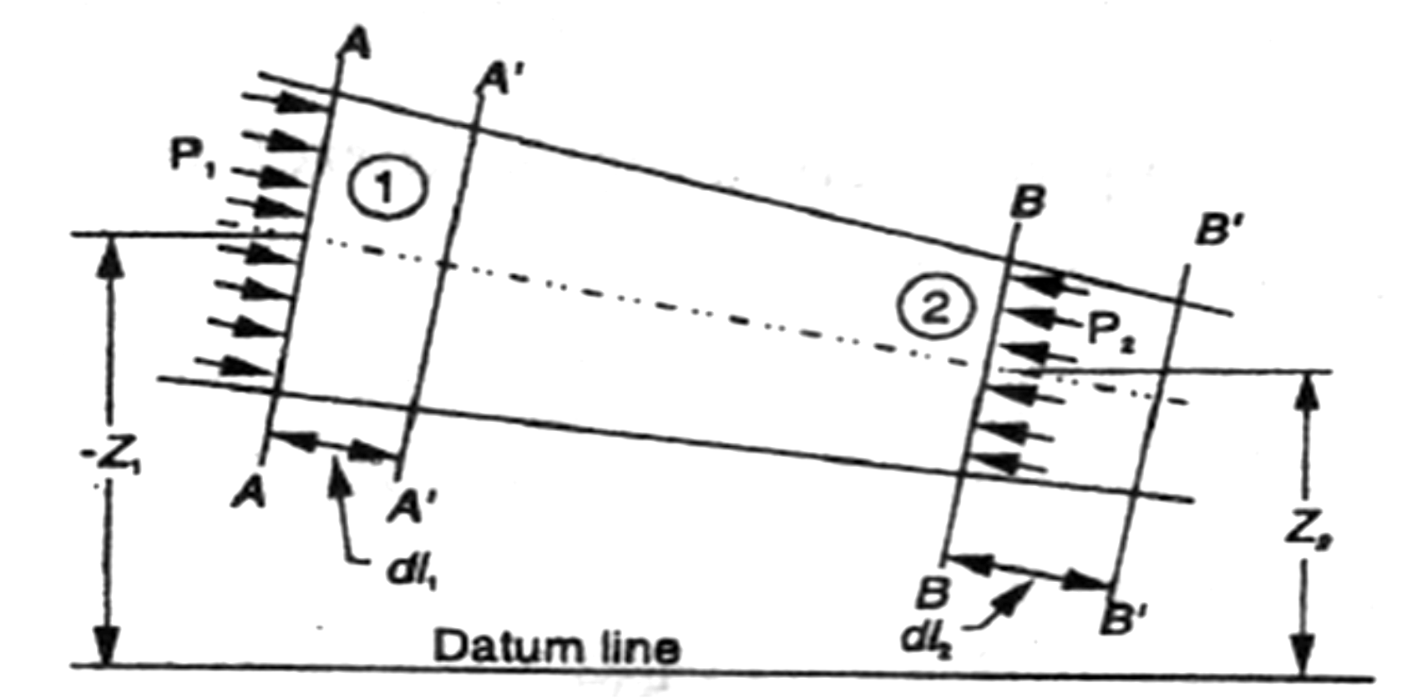
Fig. 2.1

Let us consider two sections AA and BB of the pipe. Now let us assume that the pipe is running full and there is a continuity of flow between the two sections.

Let
Z₁ = Height of AA above the datum,
P₁= Pressure at AA,
V₁ = Velocity of liquid at AA,
A₁ = Cross-sectional area of the pipe at AA, and
Z₂,P₂,V₂,A₂= Corresponding values at BB.
Let the liquid between the two sections AA and BB move to A' A' and B' B' through very small lengths dl₁ and dl₂ as shown in Fig. This movement of the liquid between AA and BB is equivalent to the movement 'of the liquid between AA and A' A' to BB and B' B', the remaining liquid between A' A' and BB being uneffected.
Let W be the weight of the liquid between AA and A' A'. Since the flow is continuous, therefore
W = wa₁dI₁ = wa₂dL₂
or a_{1 X} dl₁= ...(i)
Similarly a₂dl₂=
a₁ . dL₁ = a₂ dL₂ ...(ii)
We know that work done by pressure at AA, in moving the liquid to A' A'
= Force x Distance = P₁. a₁ . dL₁
Similarly, work done by pressure at BB, in moving the liquid to B' B'
=-P₂a₂dl₂
...(Minus sign is taken as the direction of P₂ is opposite to that of P₁)
:. Total work done by the pressure
= P₁a1dl₁- P₂a₂dl₂
=P₁a1dl₁-p_{2a}1dl₁ …(a₁dl₁=a₂dl₂)
= a₁.dl₁ (P₁- P₂) = (P₁ - P₂) …( a₁.dl₁ = )
Loss of potential energy = W (Z₁-Z₂)
and again in kinetic energy =W[(V₂²/2g)-( V₁²/2g)]=(v₂²-v₁²)
We know that loss of potential energy + Work done by pressure
= Gain in kinetic energy
W (Z₁-Z₂)+ (P₁ - P₂) =(v₂²-v₁²)
(Z₁-Z₂)+(p₁/w)-(p₂/w)=v₂²/2g-v₁²/2g
Or Z₁ + v₁²/2g+ (p₁/w)=Z₂+ v₂²/2g+(p₂/w)
which proves the Bernoulli's equation.

Euler's Equation For Motion

The "Euler's equation for steady flow of an ideal fluid along a streamline is based on the
Newton's Second Law of Motion. The integration of the equation gives Bernoulli's equation in the form of energy per unit weight of the flowing fluid. It is based on the 'following assumptions:
1. The fluid is non-viscous (i.e., the frictional losses are zero).
2. The fluid is homogeneous and incompressible (i.e., mass density of the fluid is constant).
3. The flow is continuous, steady and along the streamline.
4. The velocity of flow is uniform over the section.
5. No energy or force (except gravity and pressure forces) is involved in the flow.
Consider a steady' flow of an ideal fluid along a streamline. Now consider a small element
AB of the flowing fluid as shown in Fig.

Let
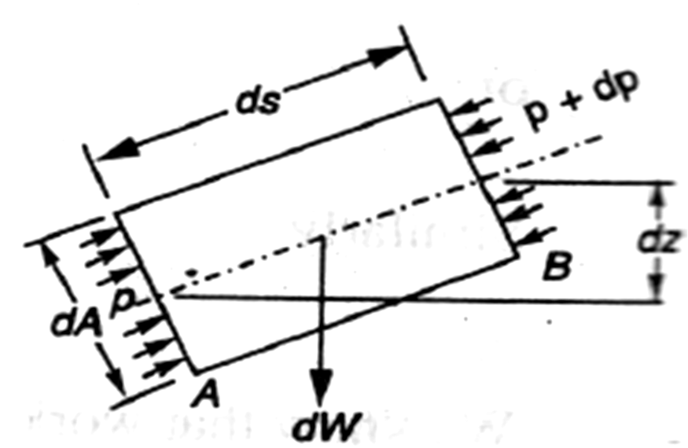
dA = Cross-sectional area of the fluid element,
ds = Length of the fluid element,
dW = Weight of the fluid 5!1ement,
p = Pressure on the element at A,
p + dp = Pressure on the element at B, and
v = Velocity of the fluid element.
We know that the external forces tending to accelerate the fluid
element in the direction of the streamline
= p. dA - (p + dp) dA Fig. 2.2
= -dp.dA
We also know that the weight of the fluid element,
dW = g. dA . ds
From the geometry of the figure, we find that the component of the weight of the fluid element
,in the direction of flow
= - g . dA . ds cos
= - g . dA . ds() …cos=
= - g. dA. dz
= .dA.ds
,We see that the acceleration of the fluid element
Now, as per Newton's Second Law of Motion, we know that
Force = Mass x Acceleration
(- dp . dA) - (g . dA . dz-) = . dA . ds
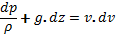 …(dividing both side by -)
Or 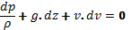
This is the required Euler's equation for motion and is in the form of a differential equation. Integrating the above equation, '
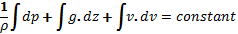
g_{z}+v²_{/2}=constant
P + wZ +Wv²/2g=constant
+Z+ v²/2g=constant (Dividing by w)
or in other words, +Z₁+(v₁²/2g)= +Z₂+(v₂²/2g)
which proves the Bernoulli's equation.

Limitations of Bernoulli's Equation:-
The Bernoulli's theorem or Bernoulli's equation has been derived on certain assumptions, which are rarely possible. Thus the Bernoulli's theorem has the following limitations:

1. The Bernoulli's equation has been derived under the assumption that the velocity of every liquid particle, across any cross-section of a pipe, is uniform. But, in actual practice, it is not so. The velocity of liquid particle in the centre of a pipe is maximum and gradually decreases towards the walls of the pipe due to the pipe friction. Thus, while using the Bernoulli's equation, only the mean velocity of the liquid should be taken into account.
2. The Bernoulli's equation has been derived under the assumption that no external force, except the gravity force, is acting on the liquid. But, in actual practice, it is not so. There are always some external forces (such as pipe friction etc.) acting on the liquid, which effect the flow of the liquid. Thus, while using the Bernoulli's equation, all such external forces should be neglected. But, ifsorne energy is supplied to, or, extracted from the flow, the same should also be taken into account.
3. The Bernoulli's equation has been derived, under the assumption that there is. no loss of energy of the liquid particle while flowing. But, in actual practice, -it is rarely so. In a turbulent flow, some kinetic energy is converted into heat energy. And in a viscous flow, some energy is lost due to shear forces. Thus, while using Bernoulli's equation, all such losses should be neglected.
4. If the liquid is flowing in a curved path, the energy due to centrifugal force should also be taken into account.

Example
The diameter of a pipe changes from 200 mm at a section 5 metres-above datum = to 50 mm at a section 3 metres above datum. The pressure of water at first section is 500 kPa. If the velocity of flow at the first section is 1 m/s, determine the intensity of pressure at the second section.
Solution.'Gi~en: d₁= 200 mm = 0.2 m; Z₁= 5 m; d2 = 50 mm = 0.05 m z₂ = 3 m; p = 500/
kPa = 500 kN/m2 and V₁ = 1 mls.
Let
V₂ = Velocity of flow at section 2, and
P₂ = Pressure at section 2. We know that area of the pipe at section 1 a₁=²=31.4210⁻³m²
and area of pipe at section 2 a₁=²=1.96410⁻³m²
Since the discharge through the pipe is continuous,therefore a₁. V₁ = a_{2.} V₂
V₂==[(31.42⁻³)]/ 1.964⁻³=16m/s
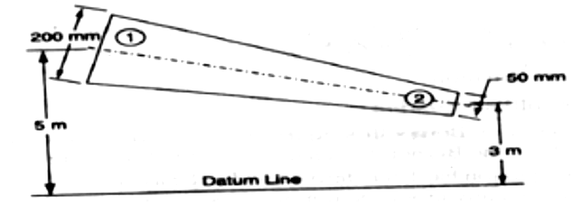

Fig. 2.3
Applying Bernoulli's equation for both the ends of the pipe,
Z₁ + v₁²/2g+ (p₁/w)=Z₂+ v₂²/2g+(p₂/w)
5+(1)²/(2) +500/9.81=3+(16)²/2X9.81+
P2 = 40 x 9.81 = 392.4 kN/m² = 392.4 kPa Ans

practical Applications of Bernoulli's Equation
The Bernoulli's theorem or Bernoulli's equation is the basic equation which has the widest applications in Hydraulics and Applied Hydraulics. Since this equation is applied for the derivation
.of many formulae, therefore its clear understanding is very essential. Though the Bernoulli's equation has a number of practical applications. yet in this chapter we shall discuss its applications on the following ‘hydraulic devices :
1. Venturi meter.
2. Orifice meter.
3. Pitot tube.

Venturimeter
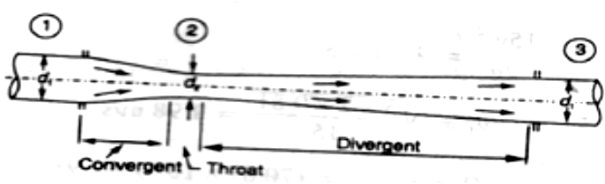

Fig. 2.4

A venturi meter is an apparatus for finding out the discharge of a liquid flowing in a pipe. A- venture meter, in its simplest form, consists of the following three parts:

(a) Convergent cone.
(b) Throat.
(c) Divergent cone.
(a) Convergent cone
It is a short pipe which converges from a diameter d₁ (diameter of the pipe. in which the venture meter is fitted) to a smaller diameter d₂: The convergent cone is also known as inlet of the venturi meter. The slope of the converging sides is between 1 in 4 or 1 in 5 as shown in Fig.
(b) Throat
It is a small portion of circular pipe in which the diameter d₂ is kept constant as shown in Fig.
(c) Divergent cone
It is a pipe, which diverges from a diameter d₂ to a large diameter d₁. The divergent cone is also known as outlet of the venture meter. The length of the divergent cone is about 3 to 4 times than that of the convergent cone as shown in Fig.

A little consideration will show that the liquid, while flowing through the venture meter, is accelerated between the sections 1 and 2 (i.e., while flowing through the convergent cone). As a result of the acceleration, the velocity of liquid at section 2 (i.e., at the throat) becomes higher than that at section 1. This increase in velocity results in considerably decreasing the pressure at section 2.1fthe pressure head at the throat falls below the separation head (which is 2.5 metres of water), then there will be a tendency of separation of the liquid flow, In order to avoid the tendency of separation at throat, there is always a fixed ratio of the diameter of throat and the pipe (i.e., dz/dt). This ratio varies from 1/4 to 3/4, but the most suitable value is 1/3 to 1/2.

The liquid, while flowing through the venture meter, is decelerated (i.e., retarded) between the sections 2 and 3 (i.e., while flowing through the divergent cone). As a result of this retardation, the velocity of liquid decreases which, consequently, increases the pressure. If the pressure is rapidly recovered, then there is every possibility for the stream of liquid to break away from the walls of the metre due to boundary layer effects. In order to avoid the tendency of breaking away the stream of liquid, the divergent cone is made sufficiently longer. Another reason for making the divergent cone longer is to minimise the frictional losses. Due to these reasons, the divergent cone is 3 to 4 times longer than convergent cone as shown in Fig.
Discharge through a Venturi meter
Consider a venture meter through which some liquid is flowing as shown in Fig.
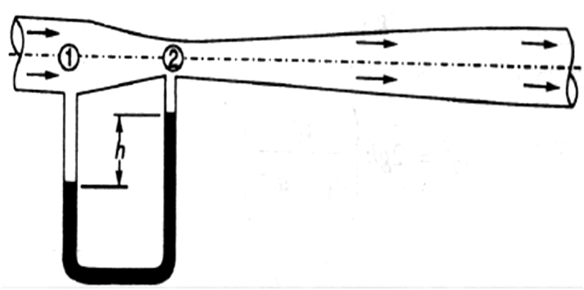
Fig. 2.5
Let
P₁ = Pressure at section 1,
V₁ = Velocity of water at section 1,
Z₁ = Datum head at section 1,
a₁ = Area of the venturi meter at section 1, and
p₂,v₂,z₂,a₂ = Corresponding values at section 2.
Applying Bernoulli's equation at sections 1 and 2. i.e
Z₁ + v₁²/2g+ (p₁/w)=Z₂+ v₂²/2g+(p₂/w) ……..(1)
Let us pass our datum line through the axis of the venture meter as shown in Fig.
Now Z₁=0 and Z₂=0
v₁²/2g+ (p₁/w)= v₂²/2g+(p₂/w)
Or (p₁/w)-( p₂/w)= v₂²/2g- v₁²/2g ……..(2)
Since the discharge at sections 1 and 2 is continuous, therefore
V₁=a₂v₂/a₁ (a₁v₁=a₂v₂)
V₁²=a₂²v₂²/a₁² ……..(3)
Substituting the above value of v₁² in equation (2),
=v₂²/2g-(a₂²/a₁²X v₂²/2g)
= v₂²/2g(1-a₂²/a₁²)= v₂²/2g[(a₁²-a₂²)/a₁²]
We know that is the difference between the pressure heads at sections 1 and 2 when the pipe is horizontal, this difference represents the venturi head and is denoted by h.
Or h= v₂²/2g[(a₁²-a₂²)/a₁²]
Or v₂²=2gh[a₁²/(a₁²-a₂²)]
v₂= [a₁/(a₁²-a₂²)]
We know that the discharge through a venture meter,
Q = Coefficient of venturi meter x a₂ v₂
=C.a₂v₂=[Ca₁a₂/(a₁²-a₂²)]
Example
A venture meter with a 150 mm diameter at inlet and 100 mm at throat is,laid with its axis horizontal and is used for measuring the flow of oil specific gravity O.9. The oil-mercury differential manometer shows a gauge difference of200 mm. Assume coefficient of the metre as O.9 Calculate the discharge in litres per minute.

Solution. Given: d₁ = 150 mm = 0.15 m; d₂ = 100 mm = 0.1 rn; Specific gravity of oil = 0.9
h = 200 mm = O.2 m of mercury and C = 0.98.

We know that the area at inlet,
a₁=²=17.6710⁻³m²

and the area at throat,
a₂=²=7.85410⁻³m²
We also know that the difference of pressure head,
H=0.2(13.6-0.9/0.9)=2.82 m of oil
and the discharge through the venturi meter,
Q= [Ca₁a₂/(a₁²-a₂²)]
=63.9 X 10⁻³m³/s=63.9lit/s Ans.

0rifice Metre
An orifice metre is used to measure the discharge in a pipe. An orifice metre, in its simplest
form, consists of a plate having a sharp edged circular hole known as an orifice. This plate is fixed inside a pipe as shown in Fig. c A mercury manometer is inserted to know the difference
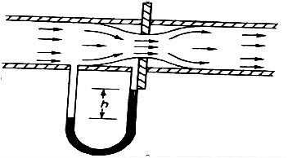
of pressures between the pipe an? the throat (i.e., orifice).
Let
h = Reading of the mercury manometer,
P₁ = Pressure at inlet,
V₁ = Velocity of liquid at inlet,
a₁ = Area of pipe at inlet, and
P₂,v₂,a₂= Corresponding values
at the throat. Fig. 2.6

Now applying Bernoulli's equation for inlet of the pipe and the throat,
Z₁ + v₁²/2g+ (p₁/w)=Z₂+ v₂²/2g+(p₂/w) ………(i)
(p₁/w)-(p₂/w)=v₂²/2g-v₁²/2g
Or h= v₂²/2g-v₁²/2g=1/2g(v₂²-v₁²) ………(ii)
Since the discharge is continuous, therefore a₁.v₁ = a₂v₂
V₁=a₂/a₁ X v₂ or v₁²=a₂²/a₁² X v₂²
Substituting the above value of v₁² in equation (ii)
h = 1/2g(v₂²-a₂²/a₁² X v₂²)= v₂²/2g X (1- a₂²/a₁²)=v₂²/2g[(a₁²-a₂²)/a₁²]
v₂²= 2gh[a₁²/(a₁²-a₂²)] or v₂= 2gh[a₁/(a₁²-a₂²)]
We know that the discharge,
Q = Coefficient of orifice metre x a₂ . v₂
=[Ca₁a₂/(a₁²-a₂²)]
Example. An orifice metre consisting of 100 mm diameter orifice in a 250 mm diameter pipe has coefficient equal to 0•65. The pipe delivers oil (sp. gr. 0•8). The pressure difference on the two sides of the orifice plate is measured by a mercury oil differential inano meter.lfthe differential gauge reads 80 mm of mercury, calculate the rate of flow in litresls.
Solution. Given: d₂ = 100 mm = 0.1 m; d₁ = 250 mm = o.25 m; C = 0.65 ; Specific gravity
of oil = 0.8 and h = 0.8 m of mercury.

We know that the area of pipe,
a₁=²=49.0910⁻³m²
and area of throat
a₂=²=7.85410⁻³m²
We also know that the pressure difference,
h = 0.8[(13.6-0.8)/0.8]=12.8 m of oil
and rate of flow,
Q=[Ca₁a₂/(a₁²-a₂²)]
=82 10⁻³ m³/s=82 lit/s Ans
Pitot Tube.

A Pitot tube is an instrument to determine the velocity of flow at the required point in a pipe or a stream. In its simplest form, a pitot tube consists of a glass tube bent a through 90° as shown in Fig.
The lower end of the tube faces the direction of the flow as shown in Fig. The liquid rises up in the tube due to the pressure exerted by the flowing liquid. By measuring the rise of liquid in the tube, we can find out the velocity of the liquid flow.
Let h = Height of the liquid in the pitot tube above the surface,
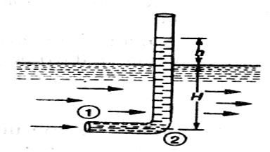

Fig. 2.7

H = Depth of tube in the liquid, and
v = Velocity of the liquid.
Applying Bernoulli's equation for the sections 1 and 2,
H+v²/2g=H+h …..(z₁=z₂)
h =v²/2g
v = 2gh
Example .
A pltot tube was inserted in a pipe to measu!e the velocity of water in it. If (
water rises the tube is 200 mm, find the velocity of water.
Solution. Given: h = 200 mm = 0.2 m.
We know that the velocity of water in the pipe,
v = 2gh = (2 x 9.81 x 0.2) = 1.98 m/s Ans.

Rate of Discharge
The quantity of a liquid, flowing per second through a section of a pipe or a channel, is known as the rate of discharge or simply discharge. It is generally denoted by Q. Now consider a liquid flowing through a pipe.
Let, a = Cross-sectional area of the pipe, and
v = Average velocity of the liquid,
:. Discharge, Q = Area × Average velocity = a.v
Notes: 1. If the area is in m² and velocity in m/s, then the discharge,
Q = m² x m/s = m³/s = cumecs
2. Remember that 1m³ = 1000 litres.
Equation of Continuity of a Liquid Flow
If an incompressible liquid is continuously flowing through a pipe or a channel (whose cross- sectional area may or may not be constant) the quantity of liquid passing per second is the same at all sections. This is known as the equation of continuity of a liquid flow. It is the first and fundamental equation of flow.
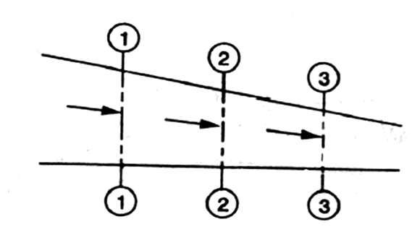
Fig. 2.8

CONTINUITY OF A LIQUID FLOW
Consider a tapering pipe through which some liquid is flowing as shown in Fig
Let , a₁ = Cross-sectional area of the pipe at section 1-1, and
v₁= Velocity of the liquid at section 1-1,
Similarly , a_{2 ,} v₂= Corresponding values at section 2-2,
and a_{3 ,} v₃ = Corresponding values at section 3-3.
We know that the total quantity of liquid passing through section 1-1,
Q₁ = a_{1.}v1 ……………………………(i)
Similarly, total quantity of liquid passing through section 2-2,
Q₂= a_{1.}v₁ ………………….(ii)
and total quantity of the liquid passing through section 3-3,
Q₃ = a_{3.}v₃ ………………….(iii)
From the law of conservation of matter, we know that the total quantity of liquid passing through the sections 1-1, 2-2 and 3-3 is the same. Therefore
Q₁ = Q₂ = Q₃ = ....... or a₁. v₁ = a₂.v₂ = a_{3.}v₃ ....... and so on.
Example : Water is flowing through a pipe of 100 mm diameter with an average velocity
10 m/s. Determine the rate of discharge of the water in litres/s. Also determine the velocity of water
At the other end of the pipe, if the diameter of the pipe is gradually changed to 200 mm.

Solution. Given: d₁= 100 mm = 0.1 m; V₁ = 10 m/s and d₂= 200 mm = 0.2 m.
Rate of discharge
We know that the cross-sectional area of the pipe at point 1,
a₁= x(0.1)²=7.854x10⁻³ m²
and rate of discharge, Q = a_{1.}v₁ = (7.854 x 10⁻³)x 10 = 78.54 X 10⁻³ m³/s
= 78.54 litres/s Ans.
Velocity of water at the other end of the pipe
We also know that cross-sectional area of the pipe at point 2,
a₂=x(0.2)²=31.42x10⁻³ m²
and velocity of water at point 2 ,v₂= = ((78.54 X 10⁻³)/( 31.42x10⁻³))=2.5m/s Ans.

2.2 Flow over Notches:-
A notch is a device used for measuring the rate of flow of a liquid through a small channel or a tank. It may be defined as an opening in the side of a tank or a small channel in such a way that the liquid surface in the tank or channel is below the top edge of the opening.
A weir is a concrete or masonry structure, placed in an open channel over which the flow occurs. It is generally in the form of vertical wall, with a sharp edge at the top, running all the way across the open channel. The notch is of small size while the weir is of a bigger size. The notch is generally made of metallic plate while weir is made of concrete or masonry structure.
1. Nappe or Vein. The sheet of water flowing through a notch or over a weir is called Nappe or Vein.
2. Crest or Sill. The bottom edge of a notch or a top of a weir over which the water flows, is known as the sill or crest.
Classification Of Notches And Weirs:-
The notches are classified as :
I. According to the shape of the opening:
(a) Rectangular notch,
(b) Triangular notch,
(c) Trapezoidal notch, and
(d) Stepped notch.
2. According to the effect of the sides on the nappe:
(a) Notch with end contraction.
lb) Notch without end contraction or suppressed notch e,
Weirs are classified according to the shape of the opening the' shape of the crest, the effect of the sides on the nappe and nature of discharge. The following are important classifications.
Discharge Over A Rectangular Notch Or Weir
The expression for discharge over a rectangular notch or weir is the same.
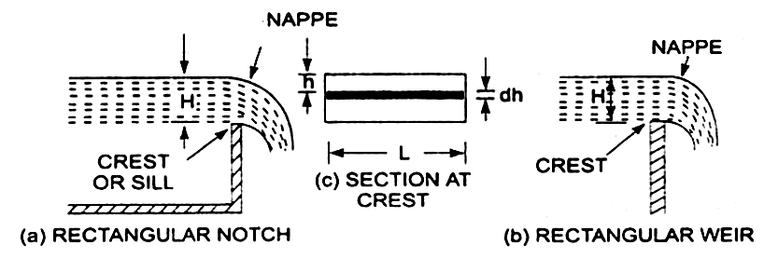

Fig. 2.9
Rectangular notch and 'weir:-
Consider a rectangular notch or weir provided in a channel carrying water as shown in Fig Let H = Head of water over the crest L = Length of the notch or weir
The total discharge, Q=c_{d} 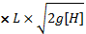^{3/2}
Problem - 1
Find the discharge of water flowing over a rectangular notch 0/2 In length when the constant head over the notch is 300 mm. Take cd = 0.60.
Solution. Given:
Length of the notch, L=2.0m
Head over notch, H = 300 m = 0.30 m
C_{d}=0.06
Discharge Q=c_{d} ^{3/2}
=1. 5 m3/s
= 3.5435 x 0.1643 = 0.582 m3/s. Ans,
Problem 2
Determine the height of a rectangular weir of length 6 m to be built across a Rectangular channel. The maximum depth of water on the upstream side of the weir is 1.8m and discharge is 2000 litres/s. Take Cd = 0.6 and neglect end contractions.
Solution. Given:
Length of weir, L=6m
Depth of water, H1=1.8m
Discharge, Q = 2000 litIs = 2 m3/s
Cd/=0.6
Let H is the height of water above the crest of weir and H2 =height of weir
The discharge over the weir is given by the equation .
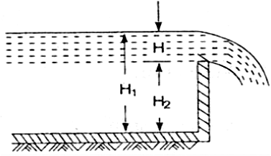
Q=c_{d} ^{3/2}
2=^{3/2}
^{=10.623} H^{3/2}
⁼ H^{3/2}= Fig. 2.10
H=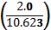^{2/3}=0.328 m
Height of weir, H2 = H1- H
= Depth of water on upstream side - H
= 1.8 - .328 = 1.472 m. Ans.

Discharge Over A Triangular Notch Or Weir:-

The expression for the discharge over a triangular notch or weir is the same. It is derived as : Let H = head of water above the V- notch
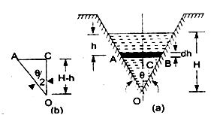
= angle of notch
Total discharge, Q=_{d}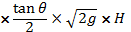^{5/2}
For a right angle V Notch ,if C_{d}=0.6
⁰, tan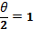
Discharge, Q = ^{5/2}
=1.417^{5/2} Fig. 2.11

Problem -1
Find the discharge over a triangular notch of angle 60° when the head over the
V-notch is 0.3 m. Assume C_{d} = 0.6.
Solution. Given an Angle of V-notch, e = 60°
Head over notch, H=0.3 m
C_{d} = 0.6
Discharge, Q over a V-notch is given by equation
Q=_{d}^{5/2}
_{d}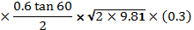^{5/2}
= 0.8182 x 0.0493 = 0.040 m3/s. Ans,

Problem -2
Water flows over a rectangular weir 1 m wide at a depth of 150 mm and afterwards passes through a triangular right-angled weir. Taking C_{d} for the rectangular and triangular weir as 0.62 and 0.59 respectively, find the depth over the triangular weir.
Solution. Given:
For rectangular weir. Length= L = 1 m
Depth of water, H = 150mm=0.15m
C_{d} = 0.62
For triangular weir.
= 90°
C_{d} = 0.59
Let depth over triangular weir = H₁
The discharge over the rectangular weir IS given by equation
Q=c_{d} ^{3/2}
=^{3/2}
=0.10635 m³/s
The same discharge passes through the triangular right-angled weir. But discharge. Q. is given by the equation
Q=_{d}^{5/2}

0.10635= 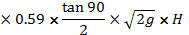₁^{5/2} { ⁰ and H=H₁ }
=₁^{5/2}
=1.3936 H₁^{5/2}
H₁^{5/2}=
H₁=(0.07631)^{0.4}=0.3572 m , Ans

Discharge Over A Trapezoidal Notch Or Weir:-

A trapezoidal notch or weir is a combination of a rectangular and triangular notch or weir. Thus the total discharge will be equal to the sum of discharge through a rectangular weir or notch and discharge through a triangular notch or weir.
Let H = Height of water over the notch
L = Length of the crest of the notch

C_{d1} = Co-efficient or discharge. for rectangular portioo ABCD of Fig.
C_{d2} = Co-efficient of discharge for triangular portion [FAD and BCE]
The-discharge through rectangular portion ABCD is given by

or Q₁=_{d1}^{3/2}

The discharge through two triangular notches FDA and BCE is equal to the discharge through a single triangular notch of angle e and it is given by equation
Q₂=_{d2}^{5/2}
Discharge through trapezoldal notch or weir FDCEF = Q₁ + Q₂
=_{d1}L^{3/2}_{d2}^{5/2}

Problem -1 Find the discharge through a trapezoidal notch which is 1 m wide at the tap and 0.40 m at the bottom and is 30 cm in height. The head of water On the notch is 20 cm. Assume C_{d} for rectangular portion = 0.62 while for triangular portion = 0.60.

Solution. Given:
Top width AE=1 m
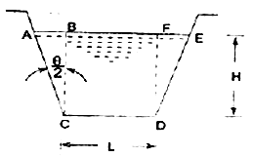
Base width, CD=L=0.4 m
Head of water, H=0.20 m
For rectangular portion, C_{d1}=0.62
From ,we have
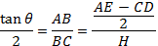
=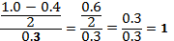 Fig. 2.12
Discharge through trapezoidal notch is given by equation
Q=_{d1}^{3/2}+_{d2}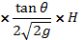^{5/2}
= x 0.62 x 0.4 x x (0.2)^{3/2} + ^{5/2}
= 0.06549 + 0.02535 = 0.09084 m³/s = 90.84 litres/s. Ans
Discharge Over A Stepped Notch:-
A stepped notch is a combination of rectangular notches. The discharge through 'stepped notch is equal to the sum of the discharges' through the different rectangular notches.
Consider a stepped notch as shown in Fig.
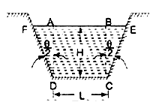
Let H₁ = Height of water above the crest of notch (1).
L₁ = Length of notch 1,
H2,L₂ and H3,L₃ are corresponding values for notches 2 and 3 respectively.
C_{d}=Co-efficient of discharge for all notches
Total discharge Q=Q₁+Q₂+Q₃
Fig. 2.12
Q=_{d11}^{3/2}-H₂^{3/2}]+_{d22}^{3/2}-H₃^{3/2}]+C_{d33}^{3/2}
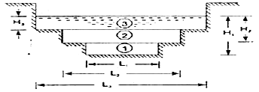

Problem Fig. 2.13
Fig. 1 shows a stepped notch. Find the discharge through the notch if Cd for all
section = 0.62.
Solution. Given:
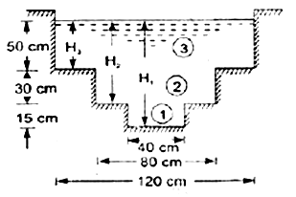
L₁ = 40 cm, L₂ = 80 cm,
L₃ = 120cm
H₁ = 50 + 30 + 15 = 95 crn,
H₂=80 cm,H₃=50 cm,
C_{d}=0.62
Total Discharge ,Q=Q₁+Q₂+Q₃
where
Q₁=_{d11}^{3/2}-H₂^{3/2}]
=[95^{3/2}-80^{3/2}]
=154067cm³/s =154.067 lit/s Fig. 2.14
Q_{2= d22}^{3/2}-H₃^{3/2}]
= [80^{3/2}-50^{3/2}]
=530141 cm³/s
=530.144 lit/s
Q₃=C_{d33}^{3/2}
^{=3/2}
=776771 cm³/s
=776.771 lit/s
Q=Q₁+Q₂+Q₃
=154.067+530.144+776.771
=1460.98 lit/s Ans.
Velocity Of Approach
Velocity of approach is defined as the velocity with which the water approaches or reaches the weir or notch before it flows over it. Thus if V_{a} is the velocity of approach, then an additional head h_{a} equal
to V_{a}² /2g due to velocity of approach, is acting on the water. flowing over the notch. Then initial height of water over the notch becomes (H+ h_{a} ) and final height becomes equal to h_{a},' Then all the formulae are
changed taking into consideration of velocity of approach.
The velocity of approach, V_{a} is determined by finding the discharge over the notch or weir neglecting velocity of approach. Then dividing the -discharge-by the cross-sectional area of the channel .on the' upstream side of the weir or notch, the velocity of approach is obtained . Mathematically,
V_{a}=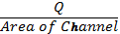
This velocity of approach is used to find an additional head (h_{a}= V_{a}² /2g ).Again the discharge is calculated and above process is repeated for more accurate discharge.
Discharge over a rectangular weir, with velocity of approach
=_{d}[(H₁+h_{a})^{3/2}-h_{a}^{3/2}]
Problem:-
Water is flowing in a rectangular channel of 1 m wide and 0.75 m deep. Find the discharge over a rectangular weir of crest length 60 cm if the head of water over the crest of weir is
20 cm and water from channel flows over the weir. Take Cd = 0.62. Neglect end contractions. Take
velocity of approach into consideration.
Solution. Given:

Area of channel, A = Width x depth = 1.0 x 0.75 = 0.75 m²
Length of weir, L = 60 cm = 0.6 m
Head of water, H₁ = 20 cm = 0.2 m
C_{d} = 0.62
Discharge over a rectangular weir without velocity of approach is given by
Q=C_{d1}^{3/2}
=^{3/2}
=0.0982 m³/s
velocity of approach V_{a}==
Additional head h_{a}=V_{a}²/2g
=(0.1309)²/2
Then discharge with velocity of approach is given by equation
Q=_{d}[(H₁+h_{a})^{3/2}-h_{a}^{3/2}]
=^{3/2}-(0.00087)^{3/2}]
= 1.098 [0.09002- .00002566]
= 1.098 x 0.09017
=0.09881 m³/s. Ans

Types of Weirs :-
Though there are numerous types of weirs, yet the following are important from the subject point of view :
1. Narrow-crested weirs,
2. Broad-crested weirs,
3. Sharp-crested weirs,
4: Ogee weirs, and
5. Submerged or drowned weirs.
Discharge over a Narrow-crested Weir :-

The weirs are generally classified according to the width of their crests into two types. i.e.
narrow-crested weirs and broad crested weirs.
Let b = Width of the crest of the weir, and
H = Height of water above the weir crest.
If 2b is less than H,the weir is called a narrow-crested weir. But if 2b is more than H . it is called a broad-crested weir.
A narrow-crested weir is hydraulically similar to an ordinary weir or to a rectangular weir .Thus, the same formula for discharge over a narrow-crested weir holds good, which we derived from an ordinary weir .
Q = X C_{d} .L x H^{3/2}
Where, Q = Discharge over the weir,
Cd = Coefficient of discharge,
L = Length of the weir, and
H = Height of water level above the crest of the weir.
Example A narrow-crested weir of 10metres long is discharging water under a constant head of 400 mm. Find discharge over the weir in litresls. Assume coefficient of discharge as 0.623.
Solution. Given: L = 10 m; H= 400 mm = 0.4 m and C_{d} = 0.623.
We know that the discharge over the weir,

Q = X C_{d} .L x H^{3/2}
= x0.623x10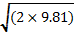 (0.4)^{3/2}
=46.55 m²/s =4655 lit/s
Discharge over a Broad-crested Weir :-
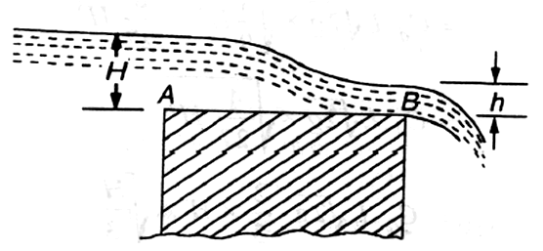

Fig. 2.15

Broad-crested weir

Consider a broad-crested weir as shown in Fig. Let A and B be the upstream and downstream ends of the weir.
Let H = Head of water on the upstream side of the weir (i.e., at A),
h = Head of water on the downstream side of the weir (i.e., at B),
v = Velocity of the water on the downstream side of the weir
(i.e., at B),
C_{d} = Coefficient of discharge, and
L = Length of the weir.
Q=1.71C_{d} .L H^{3/2}
Example A broad-crested weir 20 m long is discharging water from a reservoir in to channel. What will be the discharge over the weir, if the head of water on the upstream and downstream sides is 1m and 0.5 m respectively? Take coefficient of discharge for the flow as 0.6 .
Solution. Given: L = 20 m; H = 1 m; h = 0.5 m and C_{d} = 0.6.
We know that the discharge over the weir,
Q = C_{d} L .h
= 0.6 x 2.0 x 0.5 x m³/s
= 6 x 3.13 = 18.8 m³/s Ans.
Discharge over a Sharp-crested Weir :-

It is a special type of weir, having a sharp-crest as shown in Fig. The water flowing over the crest comes in contact with the crest -line and then springs up from the crest and falls as a trajectory as shown in Fig.
In a sharp-crested weir, the thickness of the weir is
kept less than half of the height of water on the weir. i.e.,
b<(H/2)
where , b = Thickness of the weir,
and H = Height of water, above the crest of the weir.
The discharge equation, for a sharp crested weir, remains the same as that of a rectangular weir. i.e.,
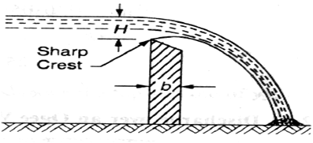

Fig. 2.16
Sharp-crested weir :-

Q = X C_{d} .L x H^{3/2}

Where, C_{d} = Coefficient of discharge, and
L = Length of sharp-crested weir

Example In a laboratory experiment, water flows over a sharp-crested weir 200 mm long under a constant head of 75mm. Find the discharge over the weir in litres/s, if C_{d} = 0.6.
Solution. Given: L = 200 mm = 0.2 m; H = 75 mm = 0.075 m and C_{d} = 0.6.
We know that the discharge over the weir,
Q = X C_{d} .L x H^{3/2}
=^{3/2}
=0.0073 m³/s =7.3 litres/s. Ans.
Discharge over an Ogee Weir :-

It is a special type of weir, generally, used as a spillway of a dam as shown in Fig.
, The crest of an agee weir slightly rises up from the
point A ,(i.e., crest of the sharp-crested weir) and after reaching the maximum rise of 0.115 H (where H is the height of a water above the point A) falls in a parabolic form as shown in Fig.
The discharge equation for an agee weir remains the same as that of a rectangular weir. i.e.,
Q = X C_{d} .L x H^{3/2}
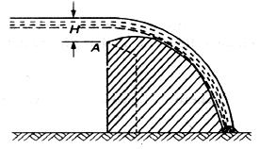
Where C_{d} = Co-efficient of discharge and
L= Length of an ogee weir

Fig. 2.17
Example
An ogee weir 4 metres long has 500 mm head of water. Find the discharge over the weir, if C_{d} = 0.62. .
Solution. Given: L = 4 m; H = 500 mm = 0.5 m and C_{d}= 0.62.
We know that the discharge over the weir,
Q = X C_{d} .L x H^{3/2}
= X 0.62 X 42 X 9.81 X (0.5)^{3/2} m³/s
= 7.323 x 0.354 = 2.59 m³/s= 2590 litres/s Ans

Discharge over a Submerged or Drowned Weir :-

When the water level on the downstream side of a weir is above the top surface of weir, it is known a submerged or drowned weir as shown in Fig
The total discharge, over such a weir, is found out by splitting up the height of water, above the sill of the weir, into two portions as discussed below:
Let H₁ = Height of water on the upstream side of the weir, and
H₂ =height of water on the downstream side
of the weir.
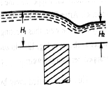

Fig. 2.18

The discharge over the upper portion may be considered as a free discharge under a head of water equal to (H₁ – H₂). And the discharge over the lower portion may be considered as a submerged discharge under a head of H₂ . Thus discharge over the free portion (i.e., upper portion),
Q1= X Cd .L x (H1-H2)^{3/2}

Submerged weir :-
and the discharge over the submerged (i.e., lower portion),
Q₂ = C_{d} . L. H₂.₁-H₂)
:. Total discharge, Q = Q₁ + Q₂

Example A submerged sharp crested weir 0.8 metre high stands clear across a channel having vertical sides and a width of 3 meters. The depth of water in the channel of approach is 1.2 meter. And 10 meters downstream from the weir, the depth of water is 1 meter. Determine the discharge over the weir in liters per second. Take C_{d} as 0.6.

Solution. Given: L = 3 m and Cd = 0.6.
From the geometry of the weir, we find that the depth
of water on the upstream side,
H₁ = 1.25 - 0.8 = 0.45 m and depth of water on the downstream side,
H₂ = 1 - 0.8 = 0.2 m
We know that the discharge over the free portion of the weir
Q₁= X Cd .L x (H1-H2)^{3/2}
=^{3/2}
= 5.315 x 0.125 = 0.664 m³/s = 664 liters/s ... (i)
and discharge over the submerged portion of the weir,
Q₂= C_{d} . L. H₂.₁-H₂)
= 0.6 x 3 x 0.2 2 x 9.81(0.45- 0.2) m³/s
= 0.36 x 2.215 = 0.797 m³/s = 797 liters/s ... (ii)
:. Total discharge: Q = Q₁ + Q₂ = 664 + 797 = 1461 liters/ s Ans.

2.3 Flow over Weirs:-
An open channel is a passage through which the water flows under the force of gravity - atmospheric pressure. Or in other words, when the free surface of the flowing water is in contact, with the atmosphere as in the case of a canal, a sewer or an aquaduct, the flow is said to be through an open channel. A channel may be covered or open at the top. As a matter of fact, the flow of water in an open channel, is not due to any pressure as in the case of pipe flow. But it is due to the slope the bed of the channel. Thus during the construction of a channel, a uniform slope in its bed is provided to maintain the flow of water.

Chezy's Formula for Discharge through an Open Channel :-
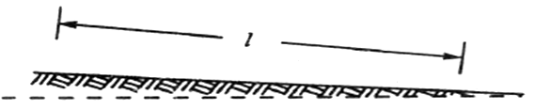

Fig. 2.19

Sloping bed of a channel :-

Consider an open channel of uniform cross-section and bed slope as shown in Fig.
Let
I = Length of the channel,
A = Area of flow,
v = Velocity of water,
p = Wetted perimeter of the cross-section, m=
f = Frictional resistance per unit area at unit velocity, and
i = Uniform slope in the bed.
m= ……..(known as hydraulic mean depth or hydraulic radious )
Discharge Q= A X v=ACmi

Example.
A rectangular channel is 1. 5 metres deep and 6 metres wide. Find the discharge through channel, when it runs full. Take slope of the bed as 1 in 900 and Chezy's constant as 50.
Solution. Given: d = 1.5 m; b = 6 m; i = 1/900 and C = 50.
We know that the area of the channel,
A = b.d = 6 x 1.5 = 9 m²
and wetted perimeter, D = b + 2d = 6 + (2 x 1.5) = 9 m
:. Hydraulic mean depth, m = = 1 m
and the discharge through the channel,
Q = ACmi = 9x50 (1 X 1/900)= 15m³/s Ans.
Manning Formula for Discharge :-

Manning, after carrying out a series of experiments, deduced the following relation for the value of C in Chezy's formula for discharge:
C=^{1/6}
where N is the Kutter's constant
Now we see that the velocity,
v = C mi=M X m^{2/3} X i^{1/2}
where
M =1/N and is known as Manning's constant.
Now the discharge,
Q = Area x Velocity = A x 1/N x m² xi^{1/2}

= A x M x m^{2/3} x i^{1/2}

Example
An earthen channel with a 3 m wide base and side slopes 1 : 1 carries water with a depth of 1 m. The bed slope is 1in 1600. Estimate the discharge. Take value of N in Manning's formula as 0.04.
Solution.
Given: b = 3 m; Side slopes = 1 : 1; d = 1 m; i = 1/1600 and N = 0.04.
We know that the area of flow,
A = x (3 + 5) x1 = 4 m²
and wetted perimeter,
P = 3 +2 X (1)²+(1)² = 5.83 m
hydraulic mean depth m = A/P=4/5.83=0.686 m
We know that the discharge through the channel
Q = Area x Velocity = A x 1/N x m^{2/3} xi^{1/2}
= 4 X 1/0.04 X 0.686^{2/3} X (1/1600)^{1/2}
=1.945 m ³/s Ans

Channels of Most Economical Cross-sections :-

A channel, which gives maximum discharge for a given cross-sectional area and bed slope is called a channel of most economical cross-section. Or in other words, it is a channel which involves least excavation for a designed amount of discharge. A channel of most economical cross-section is, sometimes: also defined as a channel which has a minimum wetted perimeter; so that there is a minimum resistance to flow and thus resulting in a maximum discharge. From the above definitions,
it is obvious that while deriving the condition for a channel of most economical cross-section, the cross-sectional area is assumed tobe constant. The relation between depth and breadth of the section is found out to give the maximum discharge.
The conditions for maximum discharge for the following sections will be dealt with in the succeeding pages :
1. Rectangular section,
2. Trapezoidal section, and
3. Circular section.

Condition for Maximum Discharge through a Channel of Rectangular Section :-
A rectangular section is, usually, not provided in channels except in rocky soils where the faces of rocks can stand vertically. Though a rectangular section is not of
much practical importance, yet we shall discuss it for its theoretical importance only.

Consider a channel of rectangular section as shown in Fig.
Let
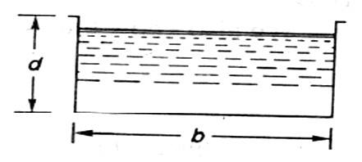
b = Breadth of the channel, and
d = Depth of the channel.
A= b X d
Discharge Q = A x v = AC mi
m=A/P
=d/2
Fig. 2.20

Hence, for maximum discharge or maximum velocity, these two conditions (i.e., b = 2d and
m = d/2) should be used for solving the problems of channels of rectangular cross-sections.

Example
A rectangular channel has a cross-section of 8 square metres. Find its size and discharge through the most economical section, if bed slope is 1 in 1000. Take C = 55.

Solution. Given: A = 8 m2

i= 1/1000 = 0.001 and C = 55.
Size of the channel
Let
b = Breadth of the channel, and
d = Depth of the channel.
We know that for the most economical rectangular section,
b = 2d
:. Area (A) 8=b X d= 2d X d =2d²
= b=2 m
And b=2d=2 X 2= 4 m
Discharge through the channel
We also know that for the most economical rectangular section, hydraulic mean depth,
m=d/2=2/2=1 m
and the discharge through the channel,
Q = AC mi= 8 x 55 1 X 0.001 m³/s
= 440 x 0.0316 = 13.9 m³/s , Ans.
Condition for Maximum Discharge through a Channel of Trapezoidal Section :-

A trapezoidal section is always provided in the earthen channels. The side slopes, in a channel of trapezoidal cross-section are provided, so that the soil can stand safely. Generally, the side slope in a particular soil is decided after conducting experiments on that soil. In a soft soil, flatter side slopes
should be provided whereas in a harder one, steeper side slopes may be provided.
consider a channel of trapezoidal cross- section ABCD as shown in FIg.

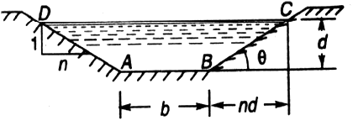

Fig. 2.21

Let
b = Breadth of the channel at the bottom,
d = Depth of the channel and
=side slope (i.e., 1 vertical to n horizontal)

Hence, for maximum discharge or maximum velocity these two
(i.e., b +2nd/2 = d and m = d/2) should be used for solving problems on channels of
trapezoidal cross-sections.

Example .
A most economical trapezoidal channel has an area of flow 3.5 m² discharge in the channel, when running 1 metre deep. Take C = 60 and bed slope 1 in 800.
Solution. Given: A = 3.5 m2 ; d = 1 m; C = 60 and i = 1/800.
We know that for the most economical trapezoidal channel the hydraulic mean depth
m = d/2 = 0.5 m
and discharge in the channel,
Q= A.C. = 5.25 m³/s Ans.
Example .
A trapezoidal channel having side slopes of 1 : 1 and bed slope of 1 in 1200 is required to carry a discharge of 1800 m³/min. Find the dimensions of the channel for cross-section. Take Chezy's constant as 50.
Solution.
Given side slope (n)=1
(i.e. 1 vertical to n horizontal),
i= 1/1200 ,Q= 180m³/min = 3m³/sec
and C = 50
Let b=breadth of the channel of its bottom and d= depth of the water flow.
We know that for minimum cross section the channel should be most economical and for economical trapezoidal section half of the top width is equal to the slopping side. i.e.
b +2nd/2 = d
or b = 0.828d
Area A = d X (b + nd) = 1.828d²
We know that in the case of a most economical trapizodial section the hydraulic mean depth m=d/2
And discharge through the channel (Q)= A.C. =1.866d^{5/2}
d^{5/2} =3/1.866 = 1.608
Or d = 1.21 m
b = 0.828 d = 0.828 X 1.21 = 1 m ANS
Condition for Maximum Velocity through a Channel of Circular Section :-
Consider a channel 'of circular section, discharging water under the atmospheric pressure shown in Fig.
Let r = Radius of the channel,
h = Depth of water in the channel, and
2 = Total angle (in radians) subtended at the centre by the water
From the geometry of the figure, we find that the wetted perimeter of the channels,
P = 2 ...(i)
and area of the section, through which the water is flowing,
A = r² - = r² ( - 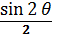) …(ii)
We know that the velocity of flow in an open channel,

Q= A.C.

We know that the velocity of flow in an open channel , v= C

Problem: Find the maximum velocity of water in a circular channel of 500 mm radius, if the bed slope is 1 in 400. Take manning’s constant as 50.

Solution:-
Given d= 500mm = 0.5m or r = 0.5/2 = 0.25m, i=1/400 and M= 50
Let 2 = total angle (in radian) subtended by the water surface at the centre of the channel.
Now we know that for maximum velocity , the angle subtended by the water surface at the centre of the channel.
2 = 257⁰30’ or = 128.75⁰ = 128.75X = 2.247rad
Area of flow, A = r² ( - ) = 171m²
And perimeter P = 2r = 1.124m
hydraulic mean depth m= A/P = 0.171/1.124 =0.152m
And velocity of water v= MXm^{2/3}Xi ^{½} = 0.71m/s ANS

Chapter-III

PUMPS

3.1 Centrifugal Pumps:-

The hydraulic machines which convert the mechanical energy to hydraulic energy are called pumps. The hydraulic energy is in the form of pressure energy. If the mechanical energy is converted, into pressure energy by means of centrifugal force acting on the fluid, the hydraulic machine is called centrifugal pump.
The centrifugal pump works on the principle of forced vortex flow which means that when a certain mass of liquid is rotated by an external torque, the rise in pressure head of the rotating liquid takes place. The rise in pressure head at any point of the rotating liquid is proportional to the square of tangential velocity of the liquid at that point (i.e. , rise in pressure head =$\frac{v^{2}}{2g}\text{or}\frac{ω^{2}r^{2}}{2g}$ ) . Thus at the outlet of the impeller, where radius is more , the rise in pressure head will be more & the liquid will be more & the liquid will be discharged at the outlet with a high pressure head. Due to this high pressure head, the liquid can be lifted to a high level.
Main Parts Of A Centrifugal Pump:-
The followings are the main parts of a centrifugal pump:
- Impeller
- Casing
- Suction pipe with a foot valve & a strainer
- Delivery Pipe
All the main parts of the centrifugal pump are shown in Fig 19.1
- Impeller: The rotating part of a centrifugal pump is called ‘impeller’. It consists of a series of backward curved vanes. The impeller is mounted on a shaft which is connected to the shaft of an electric motor.
- Casing: The casing of a centrifugal pump is similar to the casing of a reaction turbine. It is an air-tight passage surrounding the impeller & is designed in such a way that the kinetic energy of the water discharged at the outlet of the impeller is converted into pressure energy before the water leaves the casing & enters the delivery pipe. The following three types of the casings are commonly adopted:
- Volute casing as shown in Fig.19.1
- Vortex casing as shown in Fig.19.2(a)
- Casing with guide blades as shown in Fig.19.2(b)
- Volute casing as shown in Fig.3.1the Volute casing, which is surrounding the impeller. It is of spiral type in which area of flow increases gradually. The increase in area of flow decrease velocity of flow. Decrease in velocity increases the pressure of water flowing through casing. it has been observed that in case of volute casing, the efficiency of pump increases.
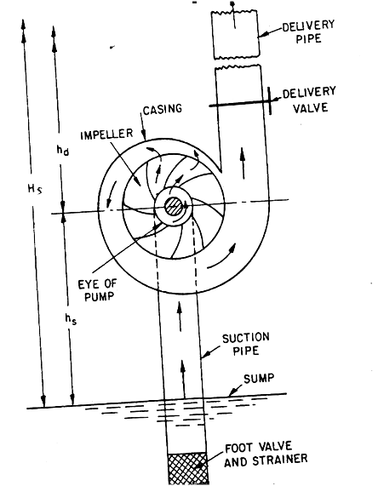
Main parts of a centrifugal pump
Fig. 3.1
b) Vortex casing. if a circular chamber is introduced between the casing and impeller as shown in fig.3.1,the casing is known as vortex casing .by introducing the circular chamber, loss of energy due to formation of eddies is reduced to a considerable extent. thus efficiency of pump is more than the efficiency when only volute casing is provided.
c) Casing with guide blades. This casing is shown in fig.3.1 in which the impeller is surrounded by a series of guide blades mounted on a ring which is known as diffuser. the guide vanes are designed in which a way that the water from the impeller enters the guide vanes without stock. Also the area of guide vanes increases, thus reducing the velocity of flow through guide vanes and consequently increasing the pressure of water. the water from guide vanes then passes through the surrounding casing which is in most of cases concentric with the impeller as shown in fig.3.1.
3. suction pipe with foot-valve and a strainer: A pipe whose one end is connected to the inlet of pump and other end dips into water in a sump is known as suction pipe. A foot valve which is a non-return valve or one –way type valve is fitted at lower end of suction pipe. Foot valve opens only in upward direction. A strainer is also fitted at lower end of suction pipe.
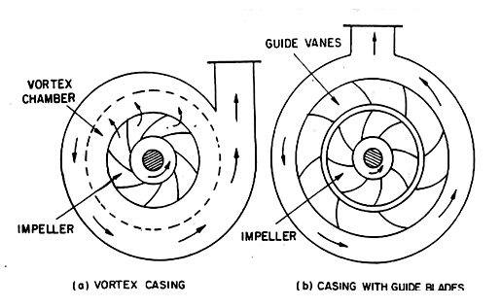

Different type of casing

Fig: 3.2
4. Delivery pipe: a pipe whose one end is connected to outlet of pump and other end delivers water at a required height is known as delivery pipe.
Efficiencies of a centrifugal pump: Efficiencies of a centrifugal pump: In case of a centrifugal pump , the power is transmitted from the shaft of the electric motor to the shaft of the pump & then to the impeller. From the impeller, the power is given to the water. Thus power is decreasing from the shaft of the pump to the impeller & then to the water. The following are the important efficiencies of a centrifugal pump:
- Manometric efficiencies$η_{\text{man}}$
- Mechanical efficiencies$η_{m}$
- Overall efficiencies$η_{o}$
- Manometric Efficiencies$η_{\text{man}}$: The ratio of the manometric head to the head imparted by the impeller to the water is known as manometric efficiency. It is written as
$η_{\text{max}}=$Manometric head∕Head imparted by impeller to water
=$\frac{H_{m}}{\frac{V_{w2}u_{2}}{g}}=\frac{{\text{gH}}_{m}}{V_{w2}u_{2}}\text{.}\text{.}\text{.}\text{.}\text{.}\text{.}\text{.}\text{.}\text{.}\text{.}\text{.}\text{.}\text{.}\text{.}\text{.}\text{.}\text{.}$
The impeller at the impeller of the pump is more than the power given to the water at outlet of the pump. The ratio of the power given to water at outlet of the pump to the power available at the impeller, is known as manometric efficiency.
The power given to water at outlet of the pump=$\frac{{\text{WH}}_{m}}{\text{1000}}\text{kW}$

The power at the impeller =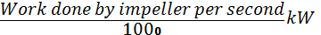
=$\begin{aligned}\frac{W}{g}×\frac{V_{w2}u_{2}}{\text{1000}}\text{kW} \\ η_{\text{max}}=\frac{\frac{{\text{WH}}_{m}}{\text{1000}}}{\frac{W}{g}×\frac{V_{w2}u_{2}}{\text{1000}}}=\frac{{\text{gH}}_{m}}{V_{w2}×u_{2}}\end{aligned}$
- Mechanical efficiencies:-
The power at the shaft of the centrifugal pump is more than the power available at the impeller of the pump . The ratio of the power available at the impeller to the power at the shaft of the centrifugal pump is known as mechanical efficiency. It is written as
$η_{m}=$ Power at the impeller∕Power at the shaft
The power at the impeller in kW=Work done by impeller per second∕10000
$\begin{aligned}=\frac{W}{g}×\frac{V_{w2}u_{2}}{\text{1000}} \\ η_{m}=\frac{\frac{W}{g}\left(\frac{V_{w2}u_{2}}{\text{1000}}\right)}{S\text{.}P\text{.}}\text{.}\text{.}\text{.}\text{.}\text{.}\text{.}\text{.}\text{.}\text{.}\text{.}\text{.}\text{.}\text{.}\text{.}\text{.}\end{aligned}$
Where S.P.= Shaft Power
- Overall efficiencies$η_{o}$
It is defined as the ratio of power output of the pump to the power input to the pump . The power output of the pump in kW
$=$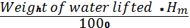=$\frac{{\text{WH}}_{m}}{\text{1000}}$
Power input to the pump =Power supplied by the electric motor
= S.P. of the pump
=$\begin{aligned}η_{o}=\frac{\left(\frac{{\text{WH}}_{m}}{\text{1000}}\right)}{S\text{.}P\text{.}}\text{.}\text{.}\text{.}\text{.}\text{.}\text{.}\text{.}\text{.}\text{.}\text{.}\text{.}\text{.}\text{.}\text{.}\text{.}\text{.} \\ η_{\text{man}}×η_{m}\text{.}\text{.}\text{.}\text{.}\text{.}\text{.}\text{.}\text{.}\text{.}\text{.}\text{.}\text{.}\text{.}\text{.}\text{.}\text{.}\text{.}\text{.}\text{.}\text{.}\end{aligned}$
Problem 3.1: The internal & external diameters of the impeller of a centrifugal pump are 200mm & 400mm respectively. The pump is running at 1200 r.p.m. The vane angles of the impeller at inlet & outlet are 20⁰ & 30⁰ respectively. The water enters the impeller radially & velocity of flow is constant. Determine the velocity of flow per metre sec.
Solution: Internal Dia. Of impeller,=D₁=200mm=0.20m
External Dia. Of impeller ,=D₂=400mm=0.40m
Speed N=1200r.p.m
Vane angle at inlet , $θ={\text{20}}^{0}$
Vane angle at outlet, $φ={\text{30}}^{0}$
Water enter s radially means, $α={\text{90}}^{0}$ and $V_{w1}=0$
Velocity of flow , =$V_{f1}=V_{f2}$
Tangential velocity of impeller at inlet & outlet are,
$\begin{aligned}u_{1}=\frac{{ΠD}_{1}N}{\text{60}}=\frac{Π×\text{.}\text{20}×\text{1200}}{\text{60}}=\text{12}\text{.}\text{56}m/s \\ u_{2}=\frac{{ΠD}_{2}N}{\text{60}}=\frac{Π×\text{.}\text{40}×\text{1200}}{\text{60}}=\text{25}\text{.}\text{13}m/s\end{aligned}$
From inlet velocity triangle,
$\begin{aligned}\text{tan}φ=\frac{V_{f1}}{u_{1}}=\frac{V_{f2}}{\text{12}\text{.}\text{56}} \\ V_{f1}=\text{12}\text{.}\text{56}\text{tan}θ=\text{12}\text{.}\text{56}×\text{tan}\text{20}=4\text{.}\text{57}m/s \\ V_{f2}=V_{f1}=4\text{.}\text{57}m/s\end{aligned}$
Problem 3.2: A centrifugal pump delivers water against a net head of 14.5 metres & a design speed of 1000r.p.m .The values are back to an angle of 30⁰ with the periphery. The impeller diameter is 300mm & outlet width 50mm. Determine the discharge of the pump if manometric efficiency is 95%.
Solution: Net head, H_{m=} 14.5m
Speed, N =1000r.p.m
Vane angle at outlet, $φ={\text{30}}^{0}$
Impeller diameter means the diameter of the impeller at outlet
Diameter, $D_{2}=\text{300}\text{mm}=0\text{.}\text{30}m$
Outlet width, $B_{2}=\text{50}\text{mm}=0\text{.}\text{05}m$
Manometric efficiency, $η_{\text{man}}=\text{95}$%=0.95
Tangential velocity of impeller at outlet, $u_{2}=\frac{{πD}_{2}N}{\text{60}}=\frac{π×\text{.}\text{30}×\text{1000}}{\text{60}}=\text{15}\text{.}\text{70}m/s$
Now using equation
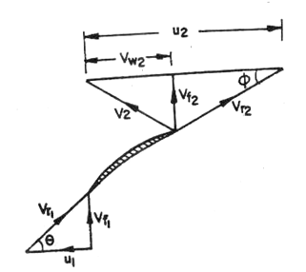
$\begin{aligned}η_{\text{max}}=\frac{{\text{gH}}_{m}}{V_{w2}u_{2}} \\ 0\text{.}\text{95}=\frac{9\text{.}\text{81}×\text{14}\text{.}5}{V_{w2}×\text{15}\text{.}\text{70}} \\ V_{w2}=\frac{0\text{.}\text{95}×\text{14}\text{.}5}{0\text{.}\text{95}×\text{15}\text{.}\text{70}}=9\text{.}\text{54}m/s\end{aligned}$

Fig. 3.3
Refer to fig(3.3). From outlet velocity triangle, we have
$\begin{aligned}\text{tan}φ=\frac{V_{f2}}{(u_{2}−V_{w2})} \\ \text{tan}{\text{30}}^{0}=\frac{V_{f2}}{(\text{15}\text{.}\text{70}−9\text{.}\text{54})}=\frac{V_{f2}}{6\text{.}\text{16}} \\ V_{f2}=6\text{.}\text{16}×\text{tan}{\text{30}}^{0}=3\text{.}\text{556}m/s \\ \text{Disch}\text{arg}e=Q=π×D×B_{2}×Valignl{\begin{aligned}f2\end{aligned}}_{}\end{aligned}=π×0\text{.}\text{30}×0\text{.}\text{05}×3\text{.}\text{556}{m^{3}}/s=0\text{.}\text{1675}{m^{3}}/s$
3.2 Reciprocating Pump:-
Introduction:-
We have defined the pumps as the hydraulic machines which convert the mechanical energy to hydraulic energy which is mainly in the form of pressure energy. If the mechanical energy is converted into hydraulic energy (or pressure energy) by sucking the liquid into a cylinder in which a piston is reciprocating (moving backwards and forwards ), which exerts the thrust on the liquid & increases its hydraulic energy (pressure energy), the pump is known as reciprocating pump.
Main parts of a reciprocating pump:-
The following are the main parts of a reciprocating pump as shown in fig (3.4)
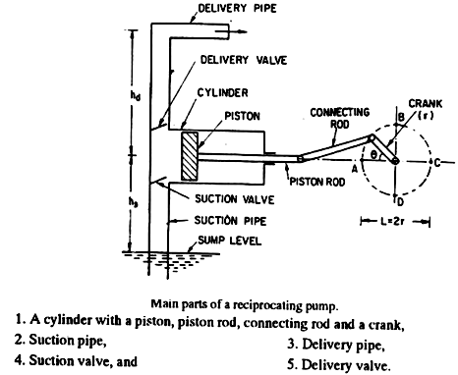
Fig. 3.4
Discharge through a Reciprocating Pump: Consider a single acting reciprocating pump as shown in fig ().
Let D= dia. Of the cylinder
A= C/s area of the piston or cylinder
=
r= Radius of crank
N=r.p.m of the crank
L=Length of the stroke=2*r
h_{s} = height of the axis of the cylinder from water surface in sump
h_{d} = Height of the delivery outlet above the cylinder axis (also called delivery head)
Volume of water delivered in one revolution or discharge of water in one revolution
= Area * Length of stroke = A*L
Number of revolution per second, =
Discharge of the pump per second , Q= Discharge in one direction × No. of revolution per second
= A×L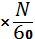 = 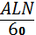 …………………………….
Wt. of water delivered per second, W = $ρ\text{gQ}=\frac{ρ\text{gALN}}{\text{60}}$ ……………………………
Work done by Reciprocating Pump : Work done by the reciprocating pump per sec. is given by the reaction as
Work done per second = Weight of water lifted per second × Total height through which water is lifted
= $W×\left(h_{s}+h_{d}\right)$
Where $\left(h_{s}+h_{d}\right)$= Total height through which water is lifted
From equation () Weight, W is given by $W=\frac{ρ\text{gALN}}{\text{60}}$
Substituting the value of W in equation () we get
Work done per second =
$\frac{ρ\text{gALN}}{\text{60}}\left(h_{s}+h_{d}\right)$…………………………………………
Power required to drive the pump, in kW 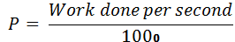 = $\frac{ρ×g×\text{ALN}\left(h_{s}+h_{d}\right)}{\text{60}×\text{1000}}$
=$\frac{ρ\text{gALN}\left(h_{s}+h_{d}\right)}{\text{60},\text{000}}\text{kW}$…………………………
Classification of reciprocating pumps:
The reciprocating pumps may be classified as:
- According to the water being in contact with one side or both sides of the piston, and
- According to the number of cylinders provided
If the water is in contact with one side of the piston, the pump is known as single-acting. On the other hand,
If the water is in contact with both sides of the piston, the pump is called double –acting. Hence, classification according to the contact of water is:
- Single-acting pump
- Double –acting pump
According to the number of cylinder provided, the pumps are classified as:
- Single cylinder pump
- Double cylinder pump
- Triple cylinder pump

